**RQ1 : User will no longer need to manually enter the age , instead user will enter the date of birth.**

This is taken care by using String.

Step 1:- Remove private int age; in User.java

Step 2:- Add private String dateOfBirth; in User.java

Step 3 :- Adding getter and setters in User.java

Step 4 :- Use the set method(setDateOfBirth() )to enter date(dd-mm-yyyy) in UserMain.java

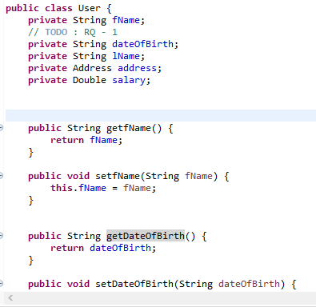

**Output:-**

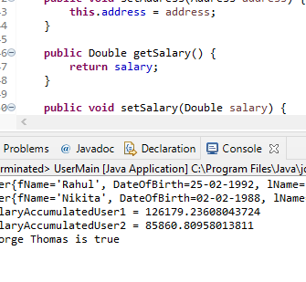

**RQ 2 : Update the logic of salaryAccumulated based on province. Details : The age of retirement of QA - 55 and ON-58**

Step 1:- converting String DateOfBirth to java.util.Date class obj

SimpleDateFormat sdf = new SimpleDateFormat("dd-mm-yyyy");

Date bofd = sdf.parse(user.getDateOfBirth());

Step 2:-calculating age

long ms = System.currentTimeMillis()-bofd.getTime();

int age = (int)((long)ms/(1000.0*60*60*24*365));

Step 3:-getting province

String province = (user.getAddress().getProvince());

Step 4:-Use if method toupdate the logic of salaryAccumulated based on province

**Output:-**

